SIMATS ENGINEERING (SAVEETHA SCHOOL OF ENGINEERING)
Department of Computer Science and Engineering
CO1 ASSESSMENT TOOL 1 – Case Study Analysis
Course Code: | CSA10 / CSA1021 | Course Title: | Software Engineering
CO Assessed: | CO1 | Assessment: | Assessment Tool 1 – Case Study Analysis
Weightage: | 20% | Total Marks: | 25
CO1 Statement: | Apply advanced methodologies and agile project management techniques to manage software projects effectively
Student Name: | S Mithun Senthil | Reg. No.: | 192324056
Date: | 13-10-2026 | Duration: | 60 minutes

Code of Conduct
I _S Mithun Senthil/192324056 certify that this submission is my original work and that I have adhered to the guidelines specified for this assessment. I understand that any violation of academic integrity rules will result in disciplinary action.
Signature of the Student: _________________________
Annexure A – Case Study Analysis
Instructions to Students:
Each student will be allotted one problem statement. Analyze the assigned problem systematically by following the steps given below. Your report should demonstrate your understanding of software engineering concepts and your ability to design an appropriate software solution.
Based on your allotted problem statement, prepare a report by answering the following questions:
- Understand the Problem Statement
- Explain the problem in your own words.
- Identify the objectives of the proposed system.
- State the scope of the problem.
- Identify Key Stakeholders and Challenges
- Identify all the stakeholders involved in the system.
- Explain the roles and responsibilities of each stakeholder.
- Discuss the major challenges and issues faced by the stakeholders.
- Analyze the Current Approach
- Describe the existing system or current process.
- Identify its strengths and limitations.
- Analyze the problems or gaps that need to be addressed.
- Propose a Suitable Solution Using Software Engineering Principles
- Design a software-based solution for the given problem.
- Describe the major functional modules of the proposed system.
- Identify the functional and non-functional requirements.
- Explain how software engineering principles such as modularity, scalability, maintainability, reliability, usability, and security are incorporated into your solution.
- Justify the Chosen Methodology/Framework
- Select an appropriate Software Development Life Cycle (SDLC) model or software development framework (e.g., Agile, Scrum, Waterfall, Spiral, DevOps).
- Justify why the selected methodology/framework is suitable for the proposed system.
- Explain how it supports successful project development and maintenance.
- Discuss Expected Outcomes and Limitations
- Describe the expected benefits of the proposed solution.
- Explain how the solution addresses the identified challenges.
- Discuss potential risks, implementation challenges, and limitations.
- Suggest possible future enhancements.
Rubrics for Calculation
Criteria | Excellent (5 Marks) | Good (3 Marks) | Satisfactory (2 Marks) | Needs Improvement (1 Mark)
Problem Understanding (30%) | Clearly explains the problem, objectives, and scope with complete understanding. | Explains the problem with minor omissions. | Basic understanding with limited explanation. | Poor understanding; objectives and scope are unclear or missing.
Stakeholder & Challenge Analysis (25%) | Identifies all stakeholders, their roles, and challenges with clear analysis. | Identifies most stakeholders and challenges with adequate analysis. | Identifies only a few stakeholders or challenges. | Stakeholders and system analysis are incomplete or inaccurate.
Current System Analysis (20%) | Thoroughly analyzes the existing system, strengths, weaknesses, and identifies all gaps. | Good analysis with most strengths and weaknesses identified. | Limited analysis with partial identification of issues. | Proposed solution is unclear or inappropriate; requirements are largely missing.
Proposed Software Solution & Software Engineering Principles (15%) | Proposes an innovative, feasible solution applying appropriate software engineering principles (modularity, scalability, maintainability, security, etc.). | Suitable solution with good application of software engineering principles. | Basic solution with limited application of software engineering principles. | Methodology is inappropriate, poorly justified, or not discussed.
Methodology/ Framework Justification (10%) | Selects the most suitable SDLC/model/framework and provides strong technical justification. | Suitable methodology selected with adequate justification. | Methodology selected but justification is weak. | Outcomes, limitations, or future enhancements are missing; report lacks organization and clarity.

Criteria | Mark
Problem Understanding (30%) | /5
Stakeholder & Challenge Analysis (25%) | /5
Current System Analysis (20%) | /5
Proposed Software Solution & Software Engineering Principles (15%) | /5
Methodology/ Framework Justification (10%) | /5
TOTAL | /25

1. Understand the Problem Statement

1.1 Problem in My Own Words

Mineral processing plants use large grinding mills to reduce raw ore into smaller particles before valuable metals such as copper or gold can be separated. These mills consume significant electrical energy and operate under demanding mechanical conditions. Their performance depends on factors such as the amount of ore inside the mill, rotational speed, grinding media, water flow, and the characteristics of the incoming rock.

The mill consumes a massive amount of electricity. Its performance depends on how much rock is inside it, how fast it rotates, and how effectively the rocks are being crushed.
There are three possible situations:

Situation 1: Too little rock :
The mill may waste energy rotating without grinding enough material. Production decreases because the machine is not being used efficiently.

Situation 2: The correct amount of rock :
The mill crushes material efficiently, uses electricity effectively, and produces the desired particle size.

Situation 3: Too much rock :
The mill can become overloaded. Grinding efficiency may fall, motor current can increase, and mechanical wear or unexpected stoppages may occur.
The main problem is this: How can we continuously determine what is happening inside the mill and automatically adjust its operation to get the best performance?
Currently, operators may rely on sensors, control systems, and their experience to make adjustments. Your project aims to make those decisions smarter using acoustic analysis, machine learning, and real-time data.
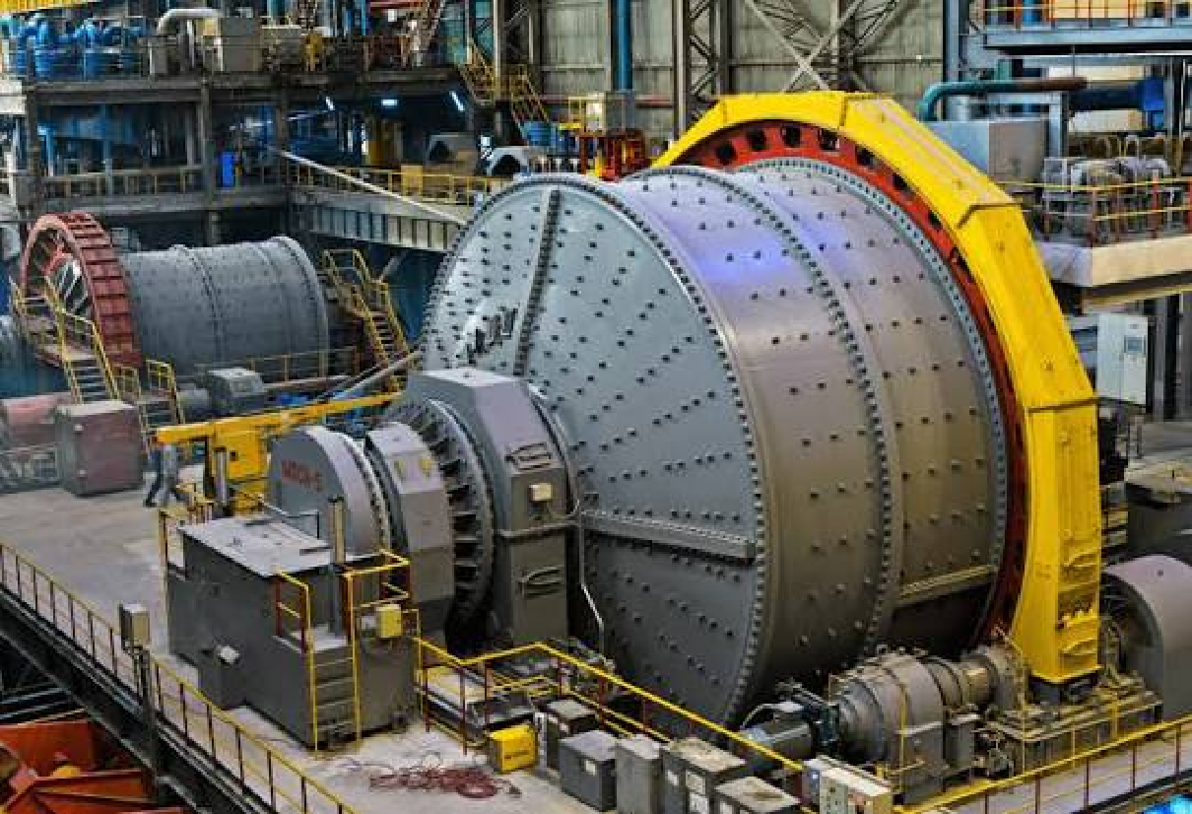

1.2 Objectives of the Proposed System

⦁Ingest high-frequency acoustic waveforms and other sensor streams with low latency, while handling noise and different sampling rates.
⦁Extract acoustic and electrical signatures that help estimate the mill’s operating state, including possible underload, normal operation, and overload.
⦁Support timely adjustment of ore-conveyor feed rates and water inputs within validated operating limits.
⦁Detect unusual trends and provide early warnings of possible bearing, liner, grinding-media, or drive-system problems where sufficient data is available.
⦁Record operational events, energy consumption, production rates, alarms, and adjustment history for reporting and enterprise-system integration.
⦁Help reduce energy use per tonne, improve throughput and product consistency, reduce avoidable downtime, and support safer maintenance planning.

Step 1: Collect sensor data

Step 2: Analyze sound and sensor signals

Step 3: Predict the mill's condition

Step 4: Optimize mill operation

Step 5: Display results

1.3 Scope of the Problem

The project scope includes sensor-data acquisition, stream processing, acoustic feature extraction, mill-state estimation, anomaly detection, decision support for feed and water adjustments, a live dashboard, historical storage, alerts, and production reports. A prototype can use simulated data and recorded audio before being tested with plant data.
The system does not independently guarantee metal recovery or equipment-life improvements. These depend on ore properties, downstream processing, mill design, sensor quality, and plant procedures. Real actuation must be integrated with the plant’s PLC/distributed control system (DCS), interlocks, and approved operating limits. Cloud software should not replace deterministic safety-critical control. The project’s success should be measured against a baseline using metrics such as kWh per tonne, tonnes per hour, particle-size consistency, false-alarm rate, and unplanned downtime.

2. Key Stakeholders and Challenges

2.1 Stakeholders, Roles, and Responsibilities

⦁ Plant operators: Monitor the mill, review alarms and recommendations, confirm abnormal conditions, and operate within approved procedures.
⦁ Process/metallurgical engineers: Define target throughput, particle-size requirements, slurry conditions, and suitable operating ranges; validate whether recommendations improve the process.
⦁ Maintenance and reliability engineers: Use condition trends and alerts to plan inspections, investigate faults, and manage liner, bearing, motor, and grinding-media maintenance.
⦁ Electrical and instrumentation technicians: Install, calibrate, inspect, and repair microphones, current sensors, temperature sensors, weight sensors, and communication equipment.
⦁ Software developers and data engineers: Build the data pipeline, analytics services, database, APIs, dashboard, logging, and integration components.
⦁ Data scientists / ML engineers: Prepare labeled data, develop and validate acoustic and anomaly-detection models, monitor model performance, and address drift.
⦁ Plant managers and production planners: Review throughput, energy, downtime, and quality reports; balance production targets, costs, and operational risks.
⦁ IT/OT cybersecurity teams: Manage user access, network segmentation, updates, backups, logging, and secure integration between information technology and operational technology.
⦁ ERP/MES administrators: Coordinate data exchange with production, inventory, maintenance, and enterprise reporting systems.
⦁ Equipment vendors and system integrators: Provide mill specifications, sensor interfaces, PLC/DCS integration guidance, and technical support.
⦁ Health, safety, and environmental personnel: Ensure proposed actions respect safety procedures, environmental targets, and applicable plant requirements.

2.2 Major Challenges Faced by Stakeholders

⦁ Harsh industrial conditions: dust, heat, moisture, vibration, and electromagnetic interference can affect sensor reliability.
⦁ Acoustic noise: conveyors, pumps, nearby equipment, and changing ore characteristics may mask the sound patterns associated with mill load.
⦁ High data rates: raw waveforms create more data than ordinary dashboard systems can efficiently store or process without filtering and edge analytics.
⦁ Limited labeled examples: confirmed overloads and equipment failures may be rare, making supervised model training difficult.
⦁ Process variability: ore hardness, particle size, mineral composition, mill speed, and water content can change the relationship between sound and load.
⦁ Latency and reliability: delayed or missing data can make recommendations stale; the system needs buffering, timestamps, health checks, and safe fallback behavior.
⦁ Trust and usability: operators need understandable recommendations, confidence indicators, explanations, and the ability to review or reject actions.
⦁ Integration and cybersecurity: connecting analytics to legacy PLC/DCS and enterprise systems requires controlled interfaces, access control, and protection against unauthorized commands.
⦁ Economic validation: energy savings and production improvements must be demonstrated under comparable operating conditions rather than assumed from model accuracy alone.

3. Analyze the Current Approach

3.1 Existing System or Current Process

The case statement does not describe one specific installed system or plant workflow. Therefore, the following is a reasonable baseline for analysis, not a claim that every plant operates this way. In a conventional process, operators monitor available instruments such as motor current, bearing temperature, feed rate, and mill speed through local panels or a SCADA/DCS interface. They may use periodic sampling, operator experience, laboratory particle-size measurements, and maintenance inspections to decide when to adjust feed or water and when to inspect equipment.
Some plants already use advanced process-control systems, vibration monitoring, or acoustic instruments. The proposed platform should complement existing controls rather than assume that all current operations are manual. Its purpose is to combine data sources, derive useful acoustic features, provide predictive insights, and document the effect of adjustments.
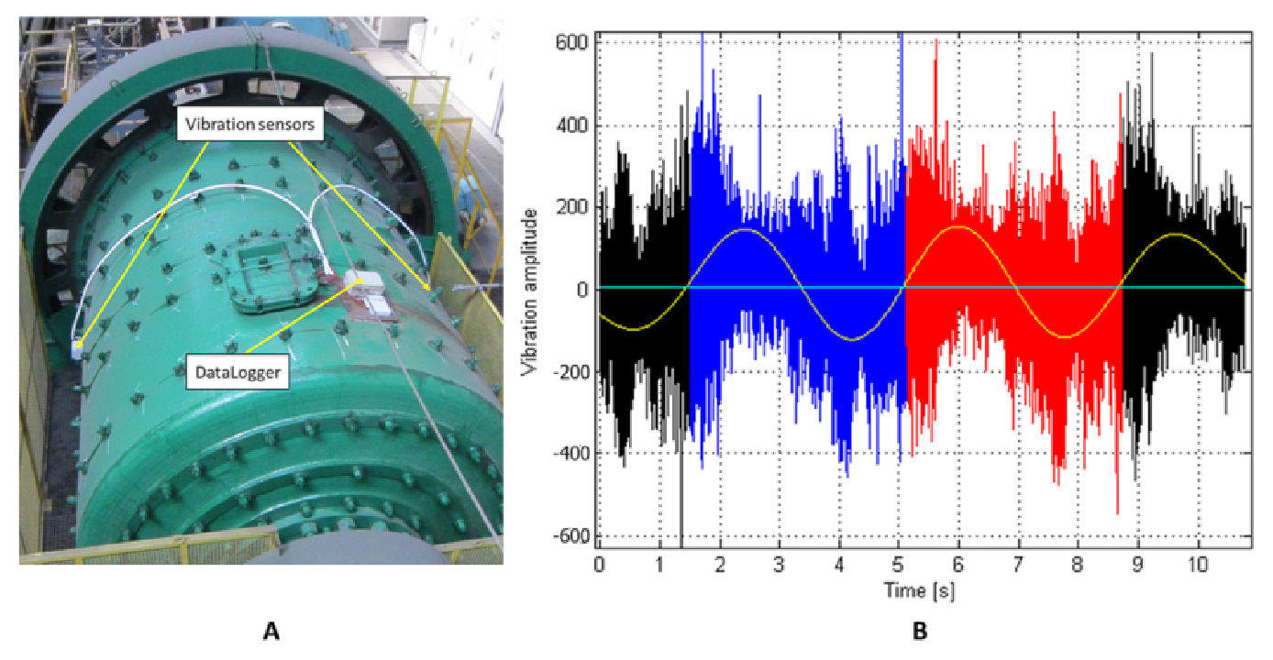
3.2 Strengths of the Current Approach

⦁ Experienced operators understand plant behavior and can recognize many abnormal conditions.
⦁ Industrial PLC/DCS systems provide established control logic, interlocks, and equipment protection.
⦁ Conventional measurements such as motor current and temperature are useful, familiar, and relatively easy to interpret.
⦁ Routine inspections and laboratory checks provide direct evidence of equipment condition and product quality.
⦁ Existing systems may be stable and already integrated into plant operating procedures.

3.3 Limitations and Gaps

⦁ Operators may not be able to interpret every high-frequency acoustic pattern in real time, especially during changing noise conditions.
⦁ Separate sensor systems can create fragmented information; combining sound, current, temperature, and feed data may require extra integration.
⦁ Manual or periodic assessment can miss fast changes between observations.
⦁ Reactive maintenance may identify wear only after performance declines or a fault becomes obvious.
⦁ Without reliable historical logging, it can be difficult to compare operating changes and quantify their impact on energy and production.
⦁ Fixed thresholds may not adapt well to different ore types, operating speeds, or normal changes in process conditions.
⦁ A prediction system can also introduce risks if its data are poor, its model is unvalidated, or its recommendations bypass existing safety controls.
The main gap is not necessarily the absence of sensors; it is the opportunity to turn multiple streams into timely, validated and actionable information. The proposed system should improve situational awareness and optimization while preserving the reliability of existing industrial controls.
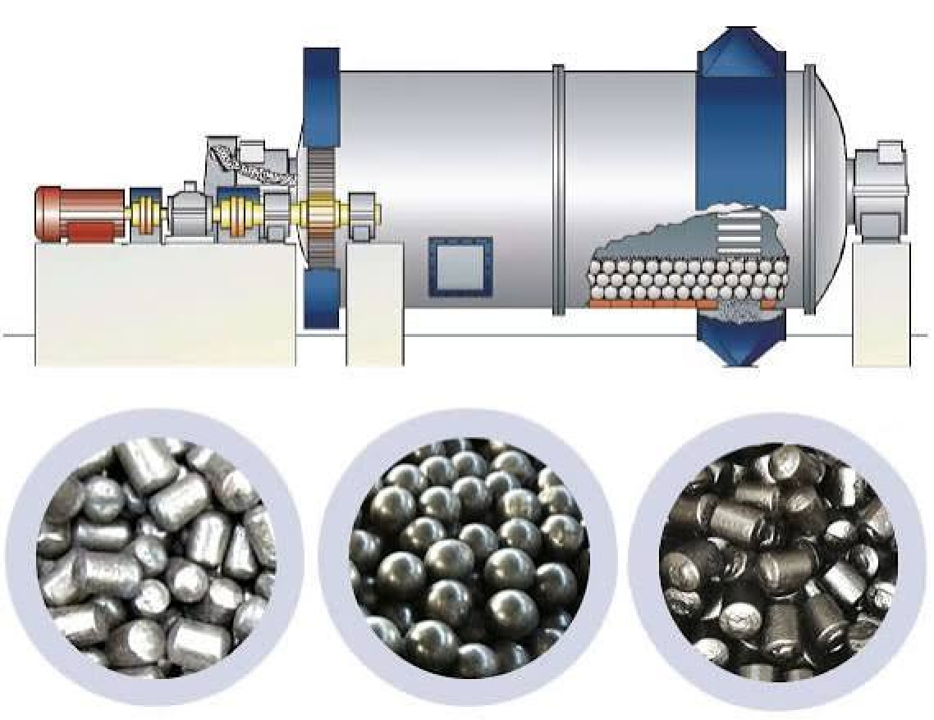

4. Proposed Software Solution Using Software Engineering Principles

4.1 Overall Solution Architecture

The platform can be designed as a layered architecture. Sensors feed an edge gateway near the mill. The gateway validates timestamps, checks signal quality, performs lightweight filtering and feature extraction, and forwards useful features or selected waveform windows to an analytics service. The analytics service estimates mill state and detects anomalies. A decision-support/control layer checks recommendations against approved limits and communicates with the PLC/DCS through a controlled interface. A database stores time-series readings and events, while a dashboard displays current status, trends, alerts, and reports.
⦁ Sensor layer: microphone array, motor-current measurement, bearing-temperature sensors, and feed-weight measurement.
⦁ Edge processing layer: timestamp alignment, signal-quality checks, noise filtering, buffering, FFT/spectrogram generation, and feature calculation.
⦁ Analytics layer: mill-load classification or regression, anomaly detection, and wear-risk estimation where training data support it.
⦁ Optimization layer: rule-based or constrained optimization recommendations for feed rate and water flow, with bounds and rate limits.
⦁ Industrial interface layer: authenticated, logged communication with the PLC/DCS; existing interlocks and control logic remain authoritative.
⦁ Data and reporting layer: time-series database, event history, user management, audit logs, and ERP/MES exports.
⦁ Presentation layer: browser dashboard for live values, operating state, recommendations, trends, and maintenance alerts.

4.2 Major Functional Modules

1. Data acquisition and validation: Collect readings, attach timestamps and equipment identifiers, detect missing or implausible values, and monitor sensor health.
2. Acoustic signal processing: Filter relevant frequency bands where appropriate, calculate RMS/energy and spectral features, generate spectrograms, and reduce noise effects.
3. Mill-state estimation: Combine acoustic features with current, temperature, and feed data to estimate operating condition; show uncertainty when the model is unsure.
4. Anomaly and wear monitoring: Detect deviations from a learned baseline and raise alerts. Remaining-life estimates should only be provided after sufficient validation data are available.
5. Optimization recommendation: Recommend feed and water changes based on state estimates, process targets, and safe limits; rate-limit changes and require operator approval where configured.
6. Dashboard and alerting: Display live status, trends, alert severity, recommended actions, acknowledgement, and sensor or model health.
7. Historical records and reporting: Store readings, decisions, operator acknowledgements, energy metrics, production totals, and maintenance events.
8. Integration and administration: Manage roles, configuration, model versions, system health, backups, audit records, and controlled interfaces to PLC/DCS and ERP/MES.
4.3 Functional Requirements

⦁ FR1: The system shall acquire acoustic and process sensor data with timestamps and equipment identifiers.
⦁ FR2: The system shall validate input quality and identify missing, stale, or out-of-range readings.
⦁ FR3: The system shall calculate acoustic features and align them with relevant process measurements.
⦁ FR4: The system shall estimate mill operating state and display the result with a confidence or quality indicator.
⦁ FR5: The system shall generate anomaly alerts based on validated rules or models.
⦁ FR6: The system shall produce feed-rate and water-flow recommendations within configured limits.
⦁ FR7: Any command sent to the industrial controller shall be authenticated, logged, bounded, and subject to plant interlocks and approval policies.
⦁ FR8: The dashboard shall display live readings, historical trends, system health, and alerts.
⦁ FR9: The system shall store operating events, model outputs, recommendations, acknowledgements, and relevant production metrics.
⦁ FR10: Authorized users shall be able to export reports and configure thresholds, users, and notification rules.

4.4 Non-Functional Requirements

⦁ Performance: edge processing should meet the latency required by the selected sampling rates and control use case; exact targets must be set during requirements analysis and tested.
⦁ Reliability: temporary network loss should not corrupt records or cause unsafe control actions; local buffering and safe fallback modes are required.
⦁ Scalability: the data pipeline should support more sensors, mills, and processing lines without redesigning the entire application.
⦁ Maintainability: modules, APIs, configuration, and model versions should be documented and independently testable.
⦁ Usability: operators should see clear status, meaningful alerts, trend plots, and actionable explanations without needing data-science expertise.
⦁ Security: role-based access, strong authentication, encrypted communication where supported, audit logs, network segmentation, and controlled updates should be applied.
⦁ Safety: the analytics platform must not override emergency stops, safety interlocks, or the authoritative PLC/DCS control logic.
⦁ Data integrity: timestamps, units, calibration details, data provenance, and model versions should be recorded so results can be traced.
⦁ Interoperability: use documented protocols and APIs compatible with plant systems, subject to site approval.

4.5 Application of Software Engineering Principles

⦁ Modularity: Separate acquisition, signal processing, analytics, optimization, storage, and UI into modules. This makes each part easier to test and replace.
⦁ Scalability: Use a streaming or message-queue design where necessary, process high-rate signals at the edge, and scale storage and analytics independently.
⦁ Maintainability: Use version control, automated tests, documented interfaces, configuration management, code reviews, and model-version tracking.
⦁ Reliability: Add health monitoring, retry and buffering logic, input validation, graceful degradation, backups, and safe fallback behavior.
⦁ Usability: Design role-appropriate dashboards, clear alarm priorities, understandable recommendation reasons, and accessible trend views.
⦁ Security: Apply least privilege, role-based access, secure secrets management, network separation between IT and OT, and audit trails.
⦁ Testability: Use unit tests for signal-processing functions, integration tests for data pipelines, replay tests for recorded sensor data, and hardware-in-the-loop tests before actuation.
⦁ Interoperability: Use stable data schemas, documented APIs, and approved industrial communication interfaces to connect plant and enterprise systems.

5. Justify the Chosen Methodology / Framework

5.1 Recommended Methodology: Agile Scrum with DevOps Practices

An Agile approach using Scrum is suitable because the project combines software, data engineering, machine learning, user-interface design, and industrial integration. Requirements such as useful acoustic features, acceptable alert rates, and operator preferences may become clearer only after prototype testing. Scrum allows the team to deliver a working increment regularly, gather feedback from stakeholders, and revise priorities.
DevOps practices can complement Scrum by automating software tests, packaging, deployment to test environments, monitoring, and controlled releases. Industrial deployment should still use formal change approval, validation, rollback plans, and site-specific safety procedures; continuous deployment directly to a live mill controller would not be appropriate.

5.2 Suggested Sprint Plan

1. Sprint 1 – Requirements and baseline: Interview operators and engineers; define target metrics, data sources, safety boundaries, and acceptance criteria.
2. Sprint 2 – Data ingestion: Build a sensor-data simulator or connector, timestamp handling, validation, and basic storage.
3. Sprint 3 – Acoustic analytics: Implement filtering and feature extraction; visualize waveform, spectrum, and spectrogram data.
4. Sprint 4 – Mill-state model: Train and evaluate a baseline classifier using labeled or simulated data; document limitations and uncertainty.
5. Sprint 5 – Dashboard and alerts: Build status cards, trends, alarms, acknowledgement, and event history.
6. Sprint 6 – Recommendation logic: Add constrained, rule-based recommendations and simulation of feed/water changes; do not connect to live actuation yet.
7. Sprint 7 – Integration and testing: Test data flow, failure recovery, permissions, model performance, and PLC/DCS interface in a controlled test environment.
8. Sprint 8 – Pilot evaluation: Run shadow-mode trials, compare predictions with operator observations, measure performance against baseline, and refine the system.

5.3 Why Scrum Supports Development and Maintenance

⦁ Short iterations make it possible to demonstrate progress instead of waiting until the entire platform is complete.
⦁ Frequent feedback from operators and process engineers helps ensure that screens, alarms, and recommendations are practical.
⦁ Prioritized backlogs let the team address high-risk work, such as data quality and safety constraints, early.
⦁ Continuous integration and automated regression tests reduce the chance that new analytics break existing functionality.
⦁ Model monitoring and planned retraining support maintenance when ore characteristics, equipment condition, or sensor behavior changes.
⦁ Sprint reviews and documented acceptance criteria provide evidence that each increment meets its intended purpose.

6. Expected Outcomes and Limitations

6.1 Expected Benefits

⦁ Energy efficiency: better load estimation and operating recommendations may reduce electricity consumed per tonne of ore.
⦁ Improved throughput: more consistent feed management may help keep the mill near an effective operating range without exceeding safe limits.
⦁ Reduced unplanned downtime: early detection of abnormal trends can give maintenance teams more time to inspect equipment.
⦁ Improved product consistency: stable grinding conditions may support more consistent particle size for downstream separation.
⦁ Better equipment management: recorded operating history and wear indicators can support inspection and replacement planning.
⦁ Improved visibility: one dashboard can bring acoustic, electrical, thermal, feed, production, and alert information together.
⦁ Traceable decisions: logs make it possible to examine what the system recommended, what operators accepted, and what happened afterward.
⦁ Environmental benefits: if the platform reduces energy use for equivalent production, associated emissions may also decrease depending on the electricity source.

6.2 How the Solution Addresses the Identified Challenges

Edge processing reduces the need to transmit every raw audio sample and can shorten the path from measurement to feature extraction. Sensor fusion makes the estimate less dependent on sound alone. Data validation and sensor-health indicators help identify unreliable inputs. Model confidence and conservative rules help prevent uncertain predictions from triggering aggressive actions. Historical storage supports trend analysis and evaluation. Finally, controlled integration with PLC/DCS, access controls, and audit logs helps preserve safety and accountability.
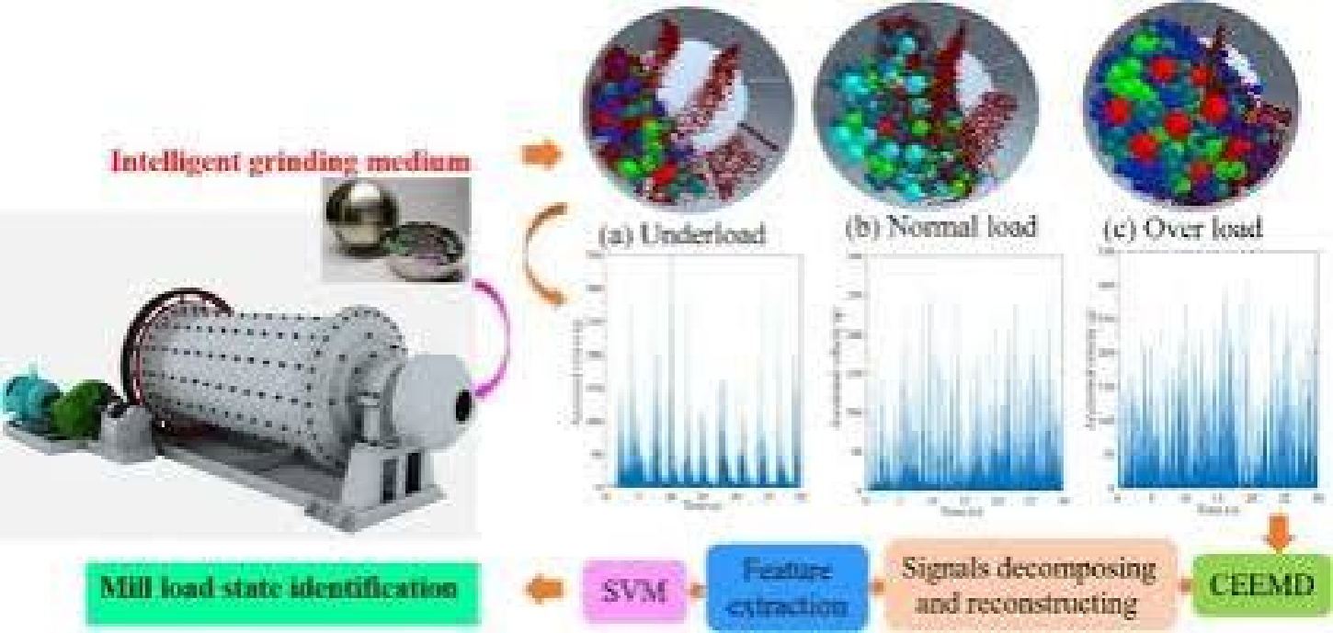

6.3 Risks, Implementation Challenges, and Limitations

⦁ Model accuracy: the sound-to-load relationship differs across mill designs, ore types, speeds, and liner conditions. A model trained on one setup may not generalize to another.
⦁ Data availability: high-quality labels for underload, overload, wear, and failure may be scarce. Simulated data are useful for a prototype but cannot prove industrial accuracy.
⦁ False alarms and missed detections: frequent false alarms can reduce operator trust, while missed faults can create risk. Thresholds and models need evaluation on representative data.
⦁ Sensor failure or drift: microphones may loosen or become obstructed; temperature and current sensors require calibration and health checks.
⦁ Control-system risk: an incorrect adjustment can destabilize the process or damage equipment. Initial operation should be advisory or shadow mode, followed by carefully approved trials.
⦁ Cybersecurity risk: unauthorized access to operational technology could disrupt production. Strong segmentation and restricted command paths are essential.
⦁ Integration cost: installing sensors, edge computers, networking, licenses, and interfaces may require plant downtime and vendor support.
⦁ Uncertain savings: benefits depend on the baseline, ore variability, operating practices, and downstream process constraints. Savings must be measured in a controlled evaluation.
⦁ Predictive maintenance limits: remaining-life predictions need adequate historical failure and maintenance records; anomaly detection alone does not establish an exact failure date.
⦁ Environmental and process constraints: water availability, slurry requirements, product-size targets, and downstream capacity can limit the optimal operating point.

6.4 Risk Mitigation Measures

⦁ Start with offline data replay and simulation; verify results before using live plant data.
⦁ Run the model in shadow mode so predictions are compared with current operation without issuing control commands.
⦁ Use independent PLC/DCS interlocks, hard operating limits, rate limits, and a defined safe fallback mode.
⦁ Require operator approval for early pilot recommendations and keep an auditable record of every action.
⦁ Validate models across different operating conditions and monitor for data drift and performance degradation.
⦁ Establish cybersecurity reviews, role-based permissions, backups, incident procedures, and controlled software releases.

6.5 Future Enhancements

⦁ Deploy a validated edge inference model optimized for low-latency processing on industrial hardware.
⦁ Use multi-sensor fusion with vibration, acoustic emission, bearing temperature, motor current, and process measurements where practical.
⦁ Develop better estimates of particle-size distribution and connect them with downstream recovery or separation metrics if suitable data are available.
⦁ Add explainable alerts showing which features or trends contributed to a prediction.
⦁ Introduce fleet-level analytics to compare multiple mills while accounting for differences in equipment and ore.
⦁ Integrate maintenance-management systems to create inspection recommendations or work orders after authorized review.
⦁ Use digital-twin or process simulation tools to evaluate possible feed and water adjustments before testing them on the plant.
⦁ Measure energy, production, water use, maintenance events, and model performance continuously to verify benefits over time.
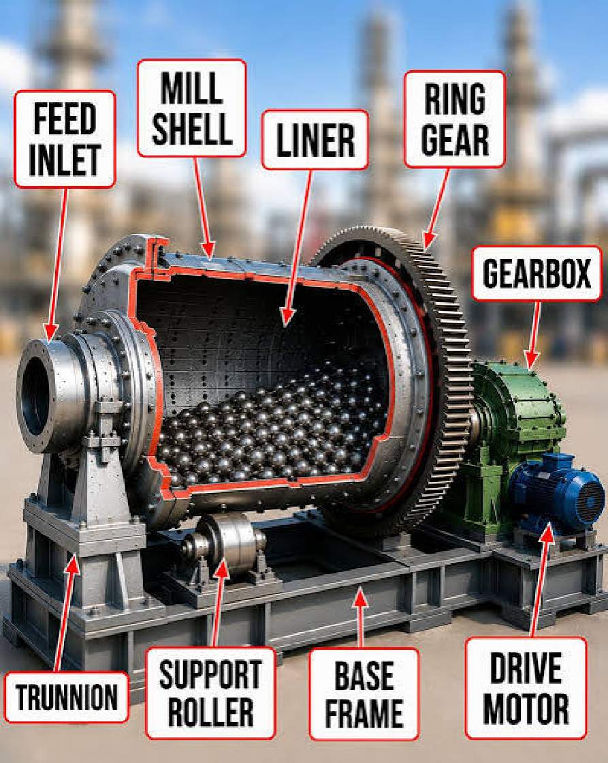

Conclusion

The High-Throughput Mineral Ore Grinding Optimization and Acoustic Mill Tuning Platform is a proposed software-intensive system for improving the visibility and efficiency of mineral grinding operations. It combines high-frequency acoustic data with motor current, bearing temperature, and ore-feed measurements to estimate mill condition, detect unusual behavior, support feed and water adjustments, and maintain production records.
A layered, modular architecture and an Agile Scrum development process are appropriate because the project contains several interacting technical components and requires frequent validation with plant stakeholders. Reliability, security, usability, maintainability, and scalability must be considered from the beginning. Most importantly, AI predictions should be treated as decision support until they are validated, and all real-world actuation must remain within approved industrial control and safety systems.
The platform’s value should be demonstrated through measured improvements—such as reduced kWh per tonne, stable or increased throughput, acceptable product quality, fewer unplanned stoppages, and useful maintenance alerts—rather than assumed in advance. Starting with simulation and shadow-mode trials provides a practical and responsible path from a college prototype to a future industrial pilot.

